Gr. 9
Exploring Technology

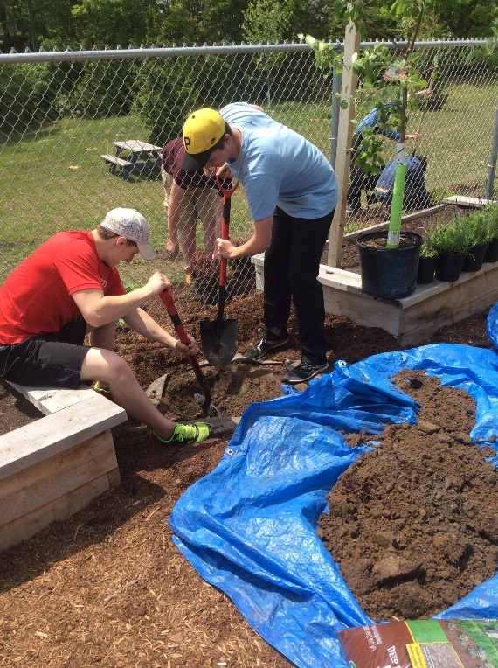
Green Industries THJ1O
Learn about agriculture forestry, horticulture, floristry and landscaping.

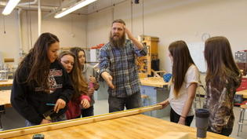

Like working with your hands? Want to gain useful every day skills? Take a look at constructions technology (tCJ10) where you will learn about plumbing, electrical and network wiring, masonry, heating/ cooling, carpentry, and woodworking
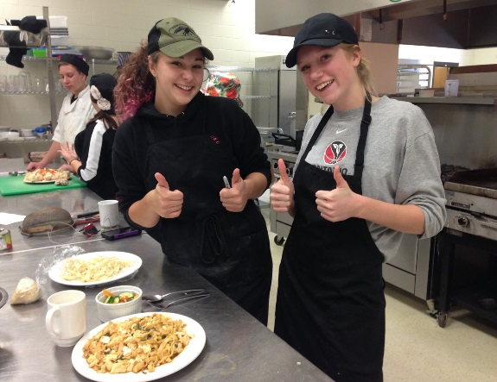
Where else can you create something with your hands and then eat the results? Try Hospitality and Tourism (TFJ1O) where we can explore safe food handling, food preparation, event planning and local foods.



Technological Design (TDJ1O) involves the development of solutions to various design challenges and the fabrication of models or prototypes of those solutions.

