
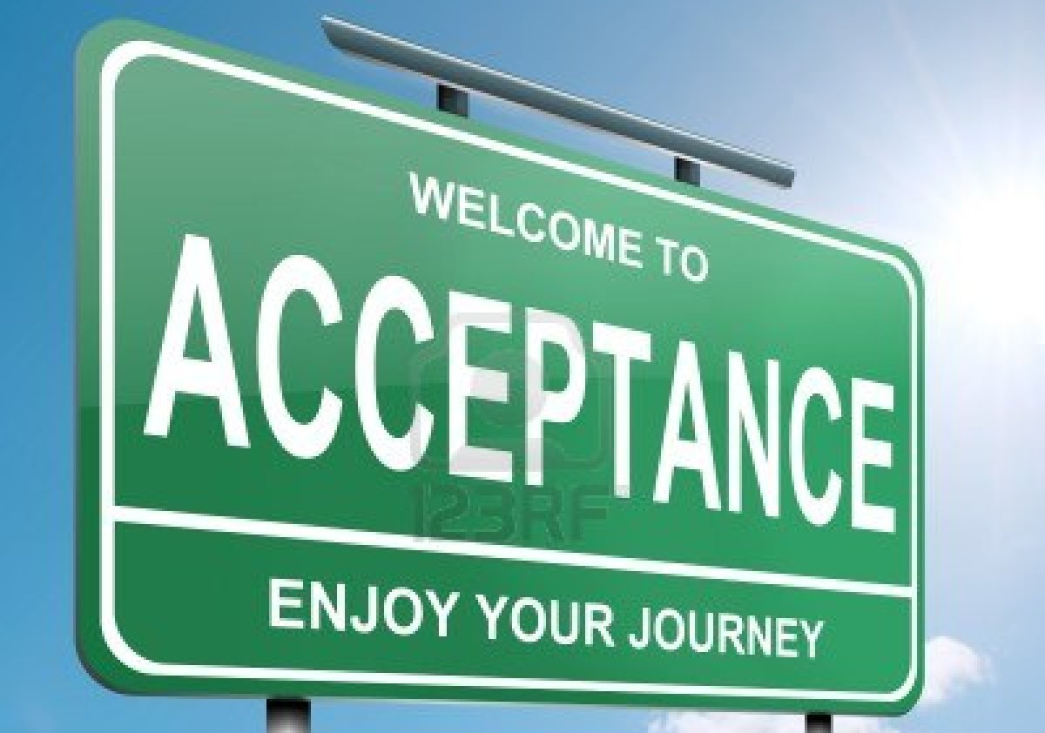

We may come from different places and have different personalities, but OUR class is a safe place for EVERYONE

